Goto Eclipse Market place
type Selenium ans search
select TestNG for Eclipse
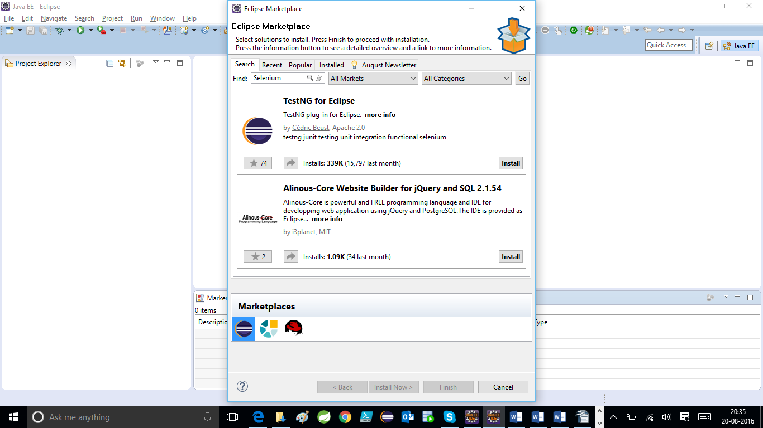
confirm TestNG

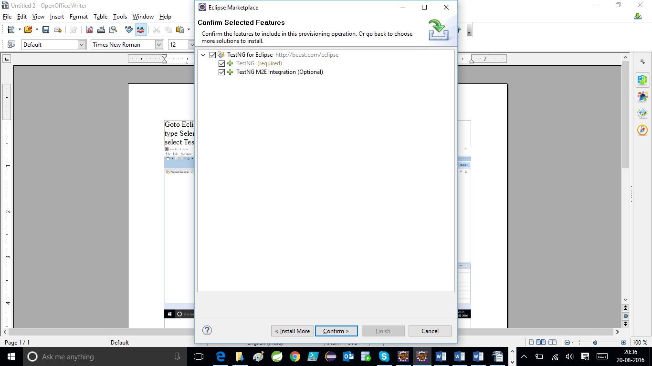
Accept the License

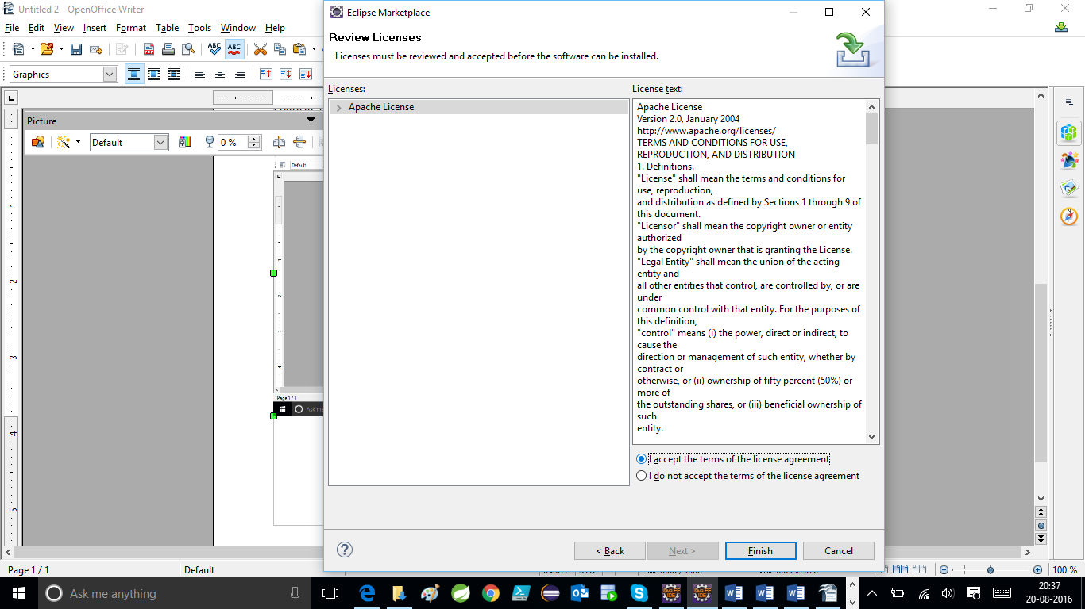
Click Finish

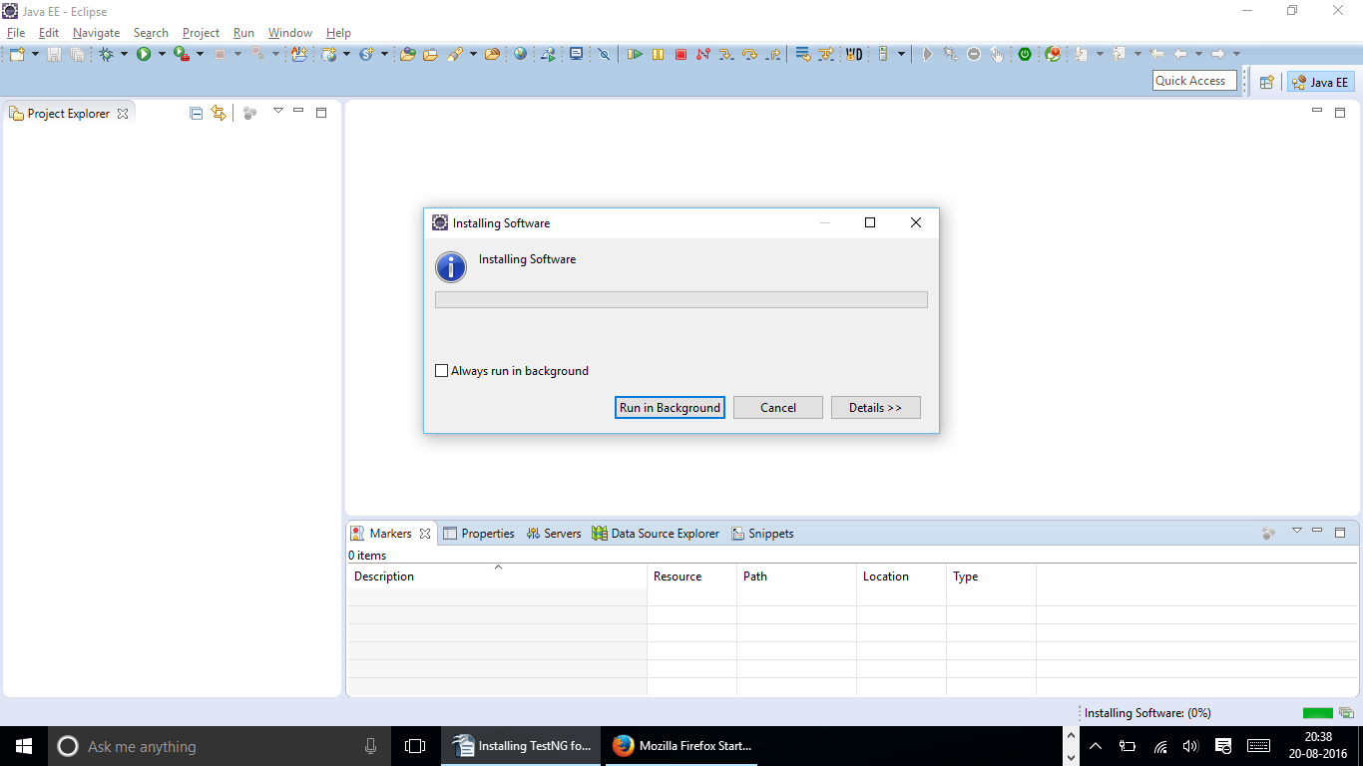
Now your Software will get installed

